World Literacy Foundation
712 H Street NE Suite 2013
Washington, D.C. 20002

Dear Andy Kay at the World Literacy Foundation,

I am Jacob Biles, a student in the Bachelor of Innovation program at the University of Colorado Colorado Springs. I have grown up having difficulty with my education, especially reading and writing. When I think of this challenging time, a quote always comes: “How do you repay someone who taught you how to read your name?” Literacy is often taken for granted, forgetting that much of the world cannot read, let alone write. Having experienced these same challenges, the lack of literacy people face is something I despise and want to see changed in the world.

Your organization has principal values that strive to support disadvantaged children and educate parents so that a love of reading is instilled. Your actions assure me that whatever circumstance an individual may face, they can accomplish their goals.

Within my Innovation course, I have collaborated with the World Literacy Foundation. I have been searching for a funder who could help you with ongoing programs. A funder that encompasses your message and goals is the Walton Family Foundation. They have an extensive focus on education outreach for students K-12. Creating a lasting impact that allows individuals to be active in the outcome of their future is something your organization strives for with its various literacy programs.

The benefit to your programs, such as Sun Books and Reading Out of Poverty, would be substantial. It allows new technology to be brought in and the projects to continue to create lasting impact. This will be a perfect fit both ways, as your organization and the Walton Foundation strive to ensure an effect rooted within the community.

Thank you so much,
Sincerely,

/Jacob Biles/ (TODO Signature)

Jacob Biles
jbiles@uccs.edu

Walton Family Foundation
P.O. Box 2030
Bentonville, AR 72712

Dear Carrie Walton Penner at the Walton Family Foundation,

We are the World Literacy Foundation, a 501-c nonprofit organization. We are the world voice advocates for literacy and have various programs worldwide. These programs assist children and families worldwide, providing resources and education where our programs are rooted in their communities. Creating lasting impact ensures individuals have an active approach to their futures. Through combined collaboration, we will be able to advance these programs.

We oversee multiple programs such as Sun Books in Ethiopia and Uganda alongside Reading Out of Poverty in Australia, to name a few. Each of these programs is tailored based on the region they assist in and the diverse cultures they are inclusive of. Adverse children and families are given resources and education through these programs to create a love of reading at home. Making a lasting impact and ensuring these otherwise afflicted people have ways to shape their future.

Working with your foundation would benefit both our organizations. Both of our organizations seek to create a lasting impact on the lives of children and families, especially within their education. Working together will ensure a win for both of our organizations, as afflicted individuals will be given the opportunity. Through this opportunity, they will be able to have an active approach to changing their future and expanding their education most fundamentally.

Sincerely,
The World Literacy Foundation

Table of Contents
Cover Letters 1-2
Agency Cover Letter 2
Funder Cover Letter 3
Summary Sheet 4-5
Illustration 6
Narrative 7-10
Recent 990/Budget 11-24
Financial Statement 25-32
Contributions 33-34
Major Contributions 33
In-Kind Contributions 34
Board of Directors 35
Proof of IRS Federal Exempt Status 36
List of Key Staff and Qualifications 37
Annual Report 38-65
Evaluation Results 66-77
World Literacy Foundation Group Financial Statement 78-81
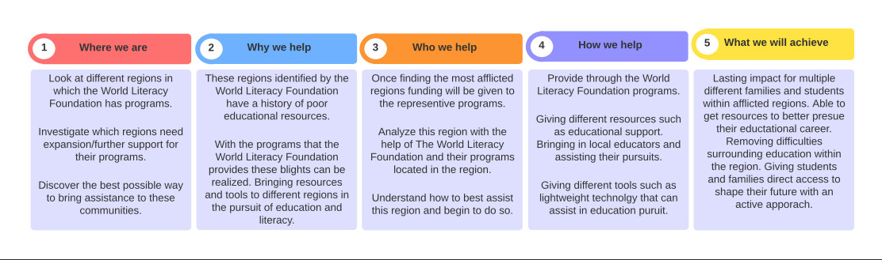

Organizational Background
The World Literacy Foundation started in 2003 in Melbourne, Australia, to help children access books when unable to access them. We then expanded our reach rapidly to Africa, the United States, and the United Kingdom. Today, each region has a unique program that reflects the needs and culture of each respective community. With these programs, we tackle the challenges of illiteracy. We are a voice for global literacy, seeking to leave a lasting impact that promotes positive change. We complete this work by providing programs that take root in a community.
Goals
Our foundation has extensive goals that focus on continuing our growth, hoping to see a world of global illiteracy in 2040. During 2022, we served 120,000 individuals, which will continue to grow. We will do this by enhancing our programs, which continue to work with local communities. Disadvantaged children will get more access to renewable technology and educational material. Through these efforts, we will provide a more significant number of children with access to resources previously unavailable while spreading these resources to adults.
In addition to our programs, we will continue to host our World Book Day avocation and Global Literacy Awards, which raise awareness about illiteracy. An example is our biannual World Literacy Summit, which will continue to educate and advocate for the importance of improving literacy across the globe. Through our efforts, we will continue to expand on all aspects of our foundation throughout the coming years in pursuit of global literacy.
Current Programs
Our global programs encompass many parts of the globe, such as Africa's Sun Books and Australia's Read Out of Poverty. Throughout these regions, over 120,000 children and parents accessed our services, with 91% showing an improvement in literacy skills. We tackle the issue of illiteracy by giving resources to children in these regions while understanding region-dependent needs. Such as the Africa region, where we introduce and maintain sustainable solar-powered technology. Through these programs, we challenge illiteracy, a global issue that costs an estimated $800 billion through our inspection.
Program Request
We request funding of $100,000 to help maintain and expand our programs. We will use this for various operations aiding the fight against illiteracy. The grant will allow us to complete program objectives for each region, such as providing more educational resources such as books or increasing sustainable technology access to most affected areas. This approach to combating illiteracy is practical, as we have seen a substantial increase in literacy skills. At the same time, having locals provides significant input, which allows these programs to take root and deliver lasting impact.
Evaluation
Our agency believes that providing in-depth evaluation allows for a substantial impact. We have multiple different impact reports evaluating the programs of each region in detail. We also produce an annual report on the global impact of each program. However, we understand that evaluation can only reveal so much and use local surveys extensively to understand better the people we help. This evaluation has revealed crucial information to our organization. We have found through providing resources such as books that 78% of recipients showed improvement in literacy skills. In addition, 91% of the children who had accessed our resources saw an improvement in their literacy skills.
Collaboration
We have a significant focus on collaboration within our agency. Most of our crucial work comes from sources such as volunteers and partners. Our volunteers are dedicated individuals who want to see a lasting impact, with a strong focus on local volunteers. Our partnerships are extensive, having various businesses and communities share their support in their cause of ending literacy. Some of our most prominent partners are organizations such as the Atmosphere Press, The Salvation Army, and African Story Book. These partnerships provide various forms of support, such as delivering supplies or services for our programs. These forces are necessary for the World Literacy Foundation to collaborate as effectively as we do.
Inclusiveness
Our Foundation focuses on inclusivity, empowering, and giving voice to indigenous communities. Local populations are a significant resource for our organization and are central to our team. The community representatives of our team are staff, volunteers, and educators representing and shaping their respective programs. Our ambassador program demonstrates the practice of inclusion. Each year, we educate local individuals to become literacy advocates, giving an inclusive platform of like-minded individuals to eradicate global illiteracy. This platform has reached over 1,500 individuals in more than 110 countries. When these advocates speak within their respective regions, they advocate for educating disadvantaged youth and developing their skills.
Board/Governance
Our board strives to face the critical issues of literacy and education and works diligently to improve our communities. Our committee members are intimately invested in the effectiveness of programs, community outreach, and eradicating global illiteracy, working diligently throughout our agency. Many members of the board work to advance our mission; the most crucial part of their work is the impact reports we produce annually. In addition, our board members are involved with other agencies and institutions, enhancing collaborative opportunities.
Volunteers
We strive to recruit and utilize volunteers daily. We understand the significance of volunteers having over 20,050 volunteer hours gifted in 2022. Volunteers perform integral parts of daily operations, giving educational and daily services to many disadvantaged youths. We host various volunteer programs, maintaining community outreach and ensuring we recruit dedicated individuals, especially those already serving these regions. We will continue to utilize volunteer forces and expand our efforts to recruit them.
Planning
We plan to continue expanding our impact throughout the future and pledge to develop and improve our program's reach. We will continue to eradicate global illiteracy and support the communities we are rooted in. At the same time, our international literacy events will continue to inspire advocates globally. We aim to continue tackling our challenges through the coming years. With the reach of our foundation, there are numerous regional challenges we must face. For example, renewable technologies are severely needed within our Sun Books program. We will continue to tackle these regional challenges and bring lasting change with sustainable solutions.

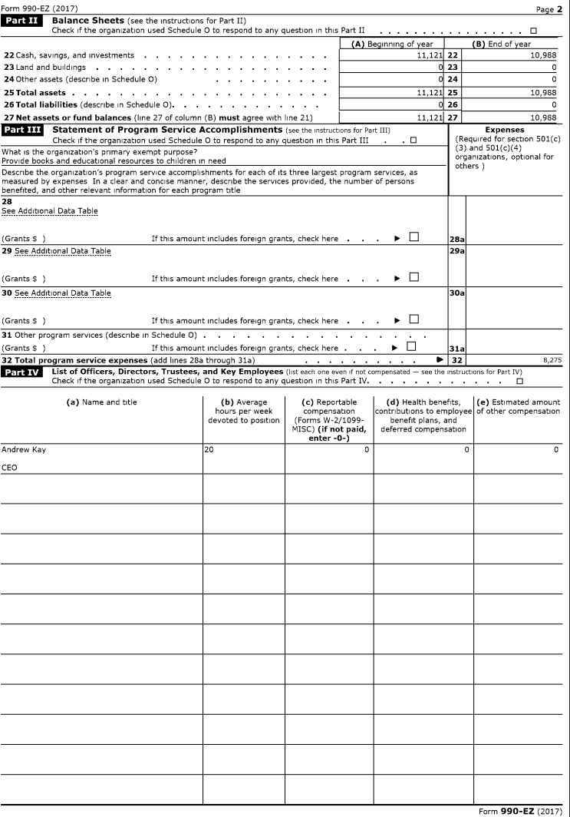


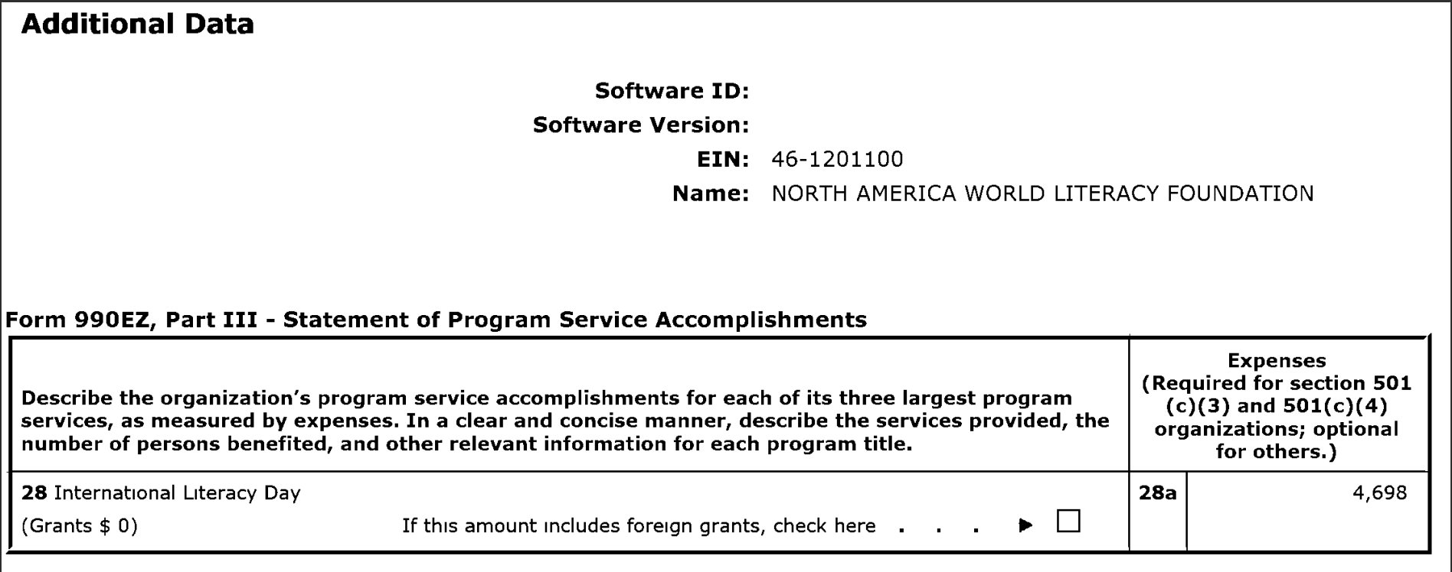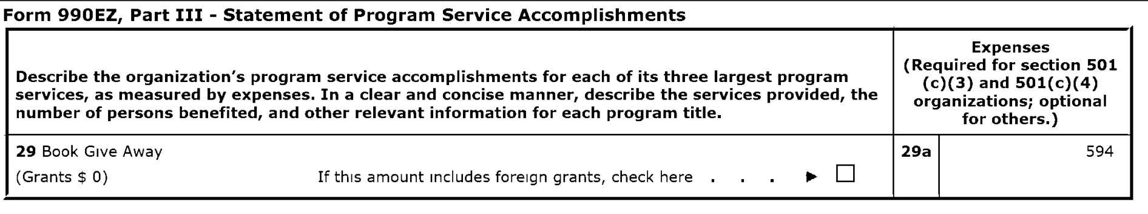
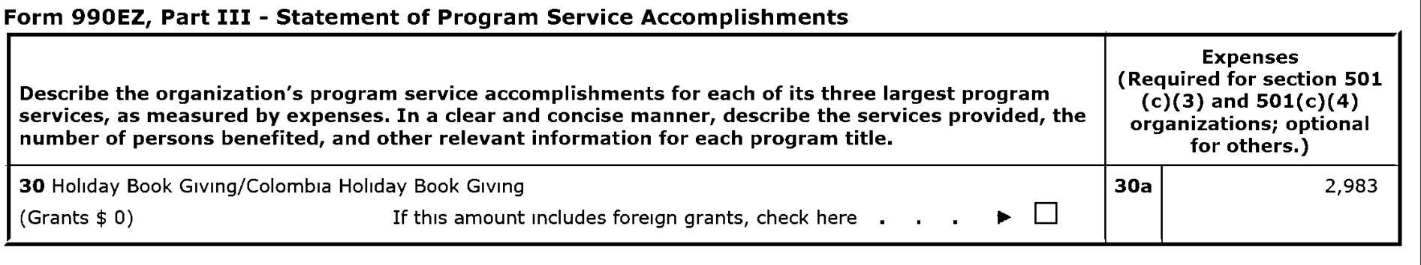








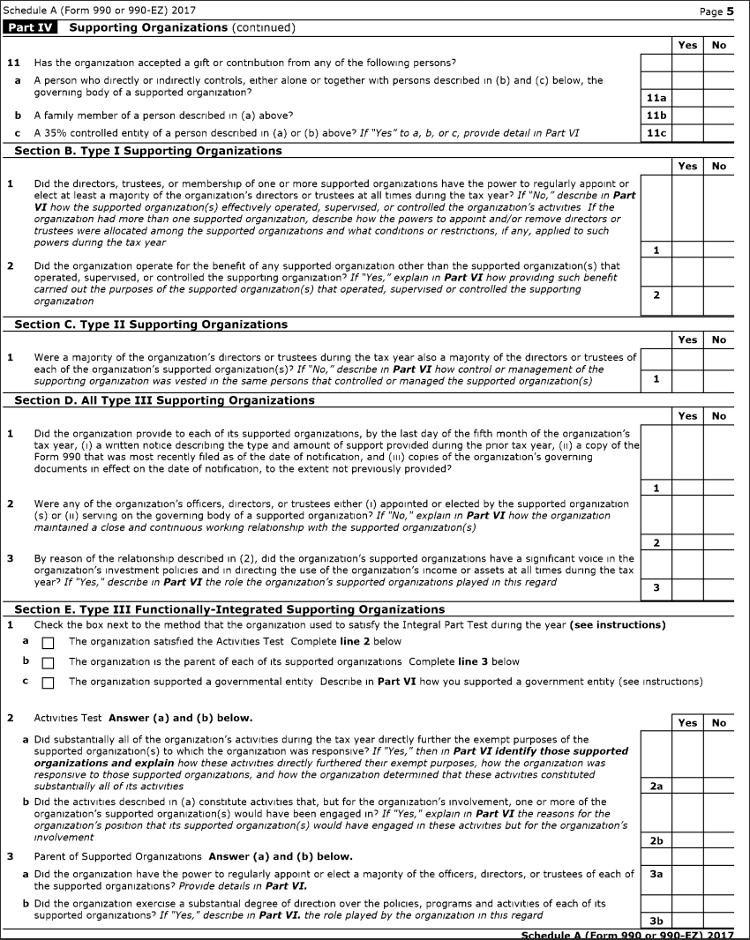

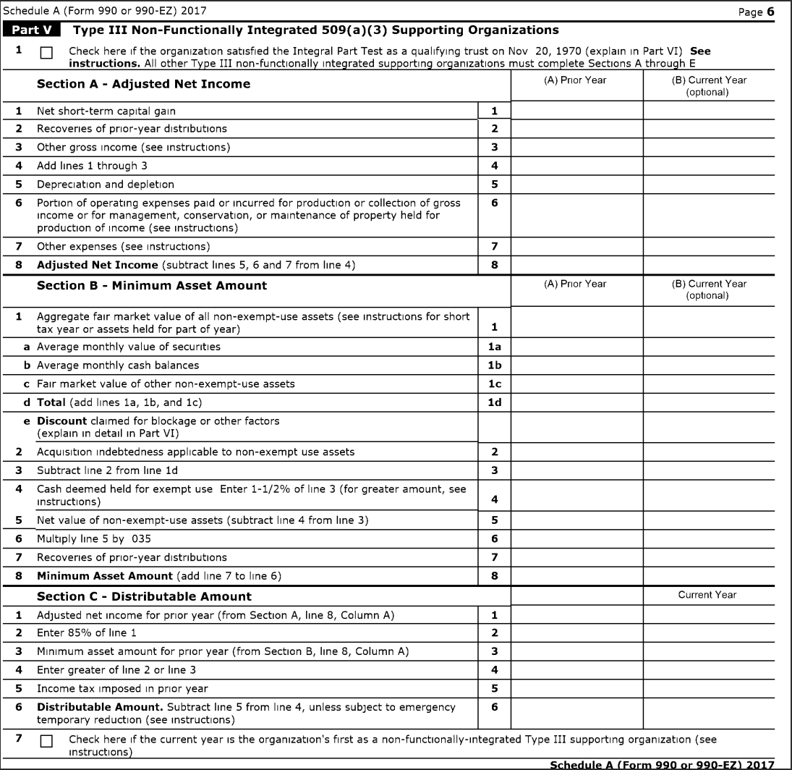





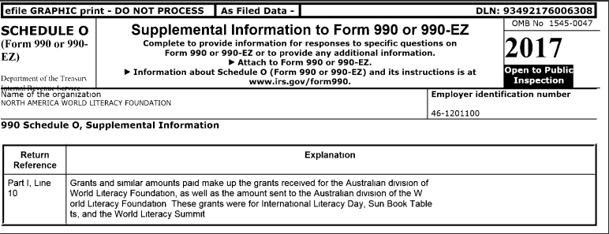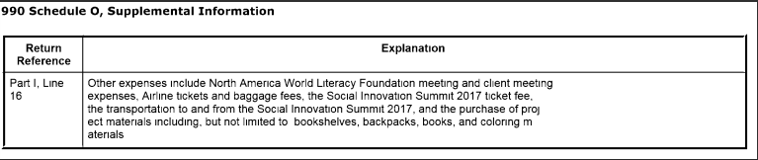

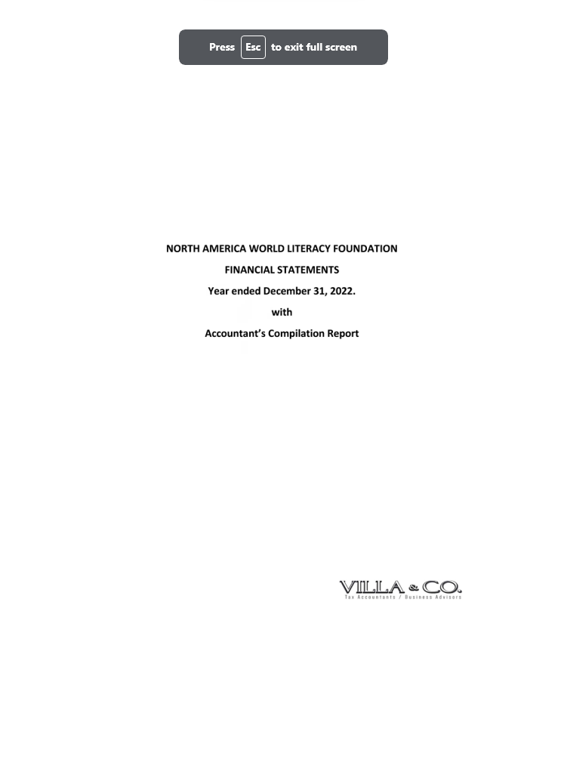
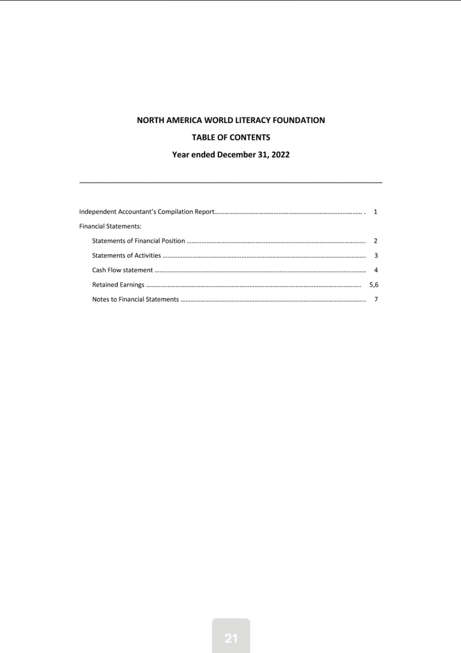
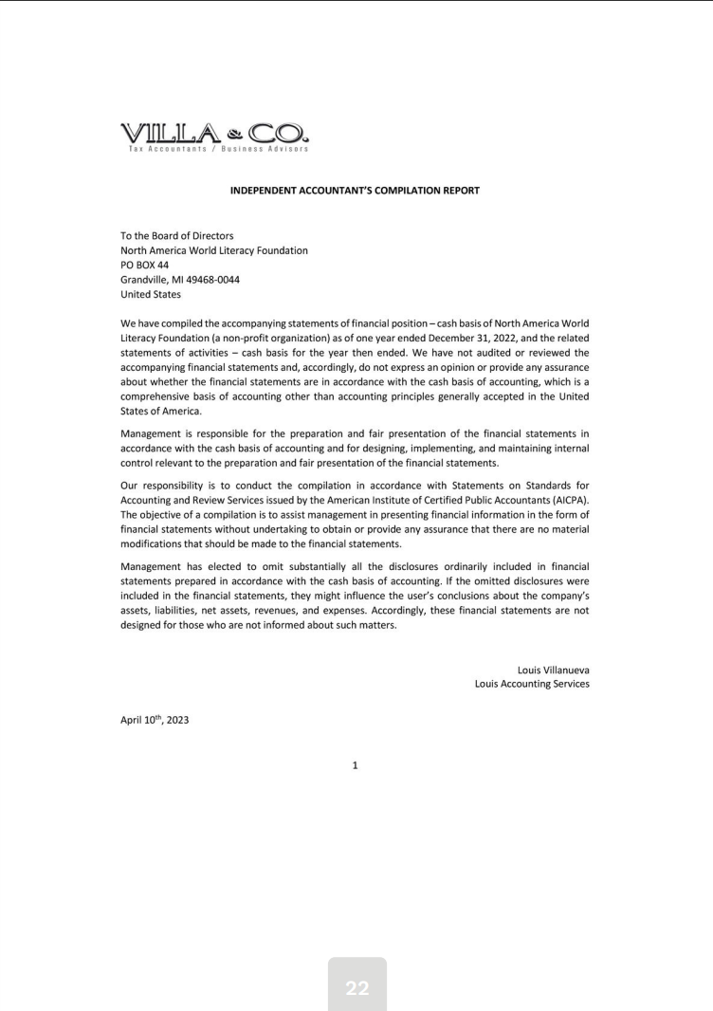
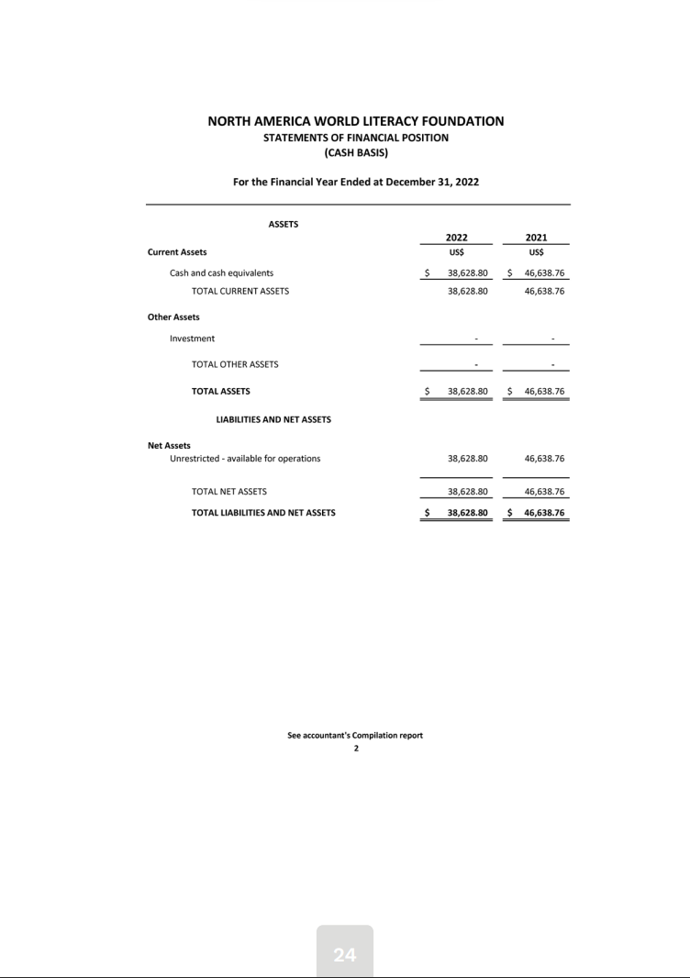
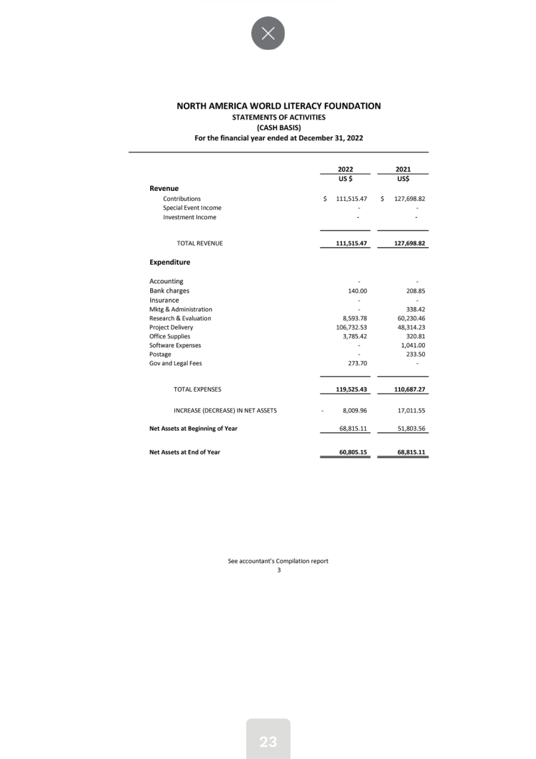
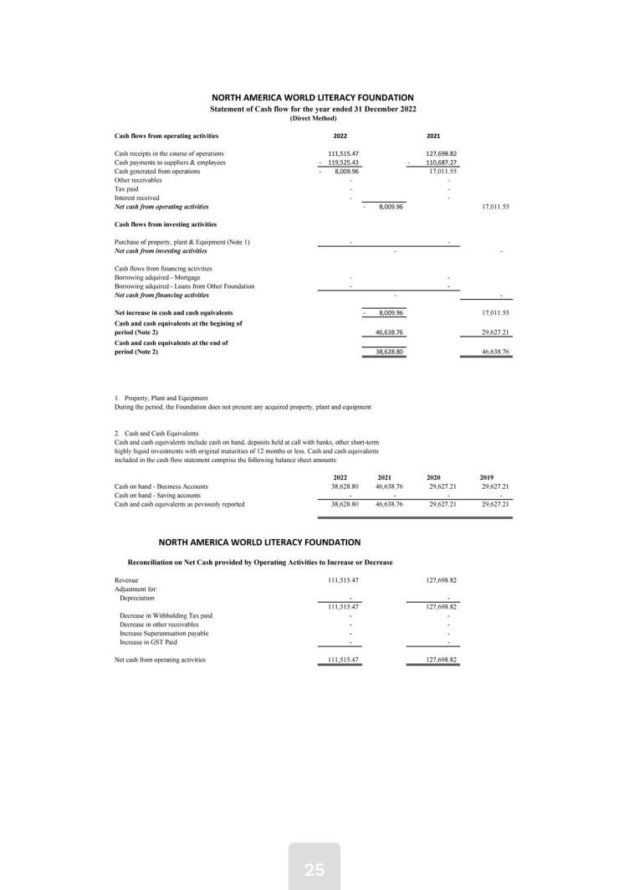
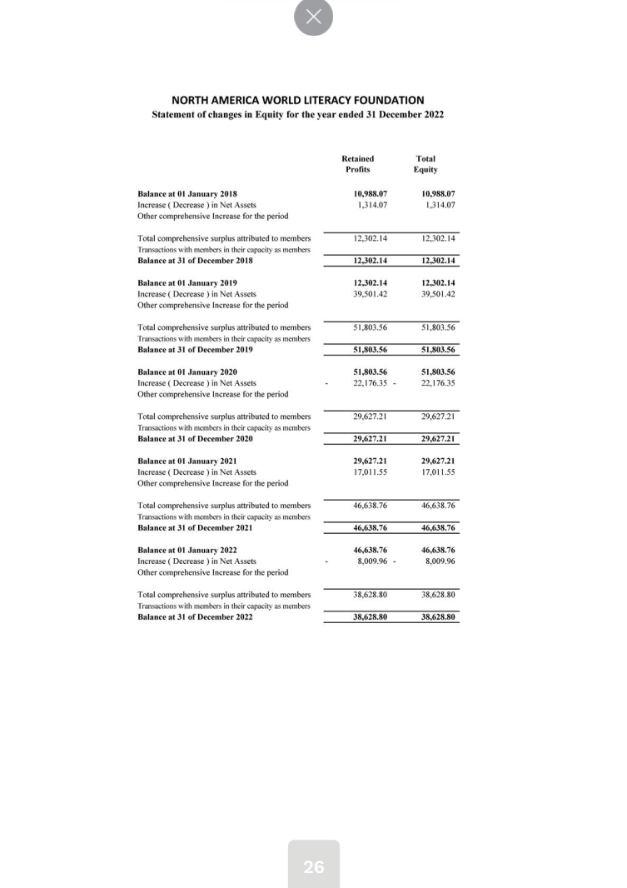
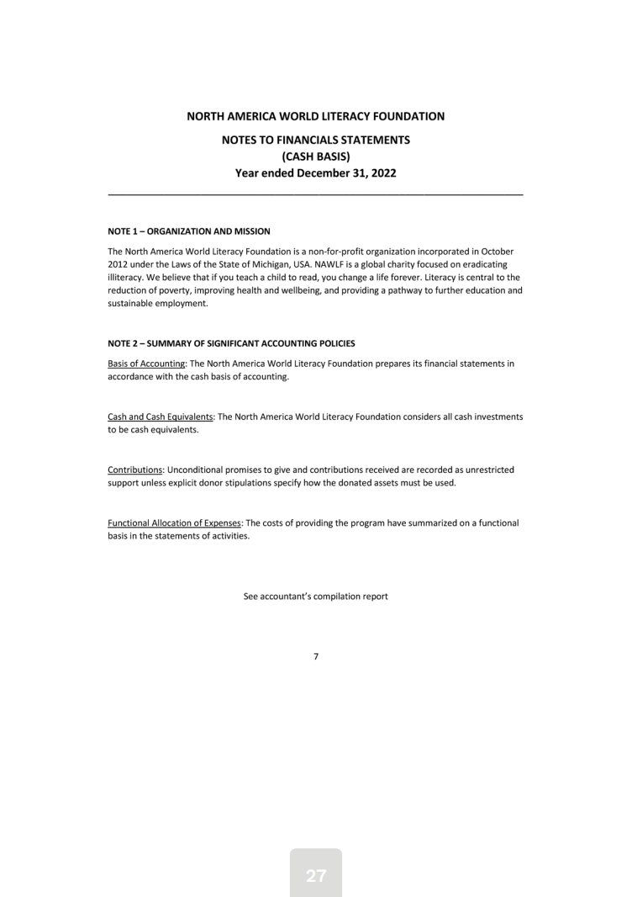
Major Contributions
We have different contributors from across the globe. These include the Australian Aid, African Storybook.org, The Salvation Army, and FedEx. We receive various monetary and service resources from these different organizations. These organizations provide support that helps make the eradication of illiteracy a reality. While also helping us maintain inclusive relations with the communities they are rooted in.
In addition to our partnerships, we give planned and legacy-giving opportunities. Legacy-giving allows for empowered individuals to make a lasting impact. We connect with these donors by having our direct contact be our founder and CEO. We respect how these donors wish their funds to impact and have that conversation start early.
These significant contributions help eradicate global literacy. The contributions help us develop renewable and sustainable technologies and resources for disadvantaged youth in an inclusive manner. These solutions help eradicate illiteracy, improving more than 90% of youths' literacy ability.

In-Kind Contributions
We understand the significance of in-kind donations. We have various platforms within our website and organization for individuals to donate. On our website, we have a donation section where we list each level of impact. In addition to our conventional donation method, we offer more modern cryptocurrency transactions. We want our donors to understand the impact of their donation. Within our home page, we describe the effective use of each gift and let the donor know the effect their offering will have. Within this donation, we ask for a monthly contribution and an intense support form for our agency.
In addition to having online donation options, our agency provides different fundraising campaigns to support our operations. We want community members to work alongside our agency and advocate for global literacy. On our website, our fundraising section outlines how to start a fundraising campaign with us. We want the involved individuals to understand their impact, listing our various statistics on what their contributions achieve.

