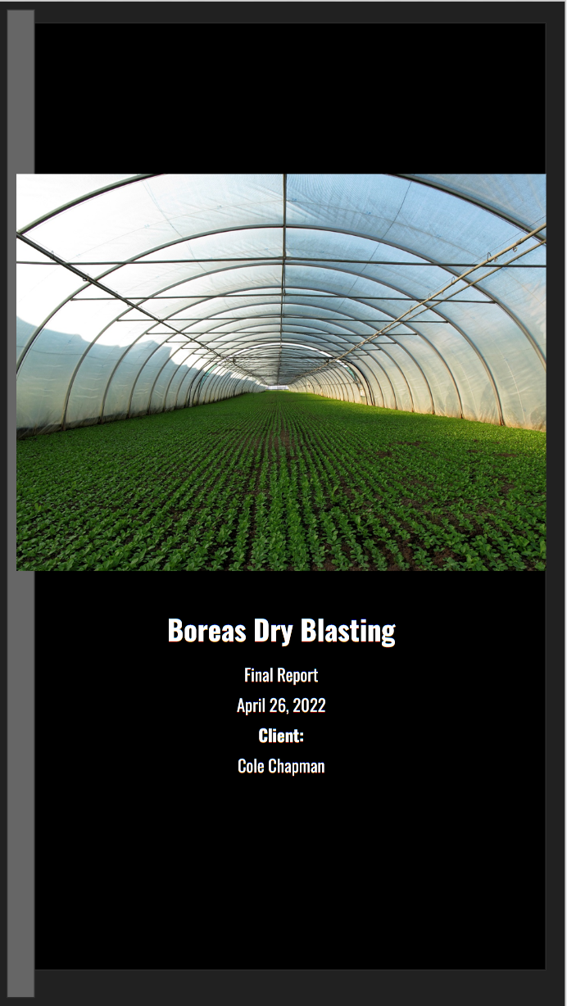

Table of Contents

**Student Biography** **4**

**Cover Letter** **5**

**Boreas Dry Ice Cleaning Corporate Scope of Work** **6**

**Abstract** **10**

**Part 1: Dry Ice Blasting Research** **11**

Established Dry Ice Blasting 11

Dry Ice Blasting in Colorado 11

Beyond Colorado 12

Dry Ice Blasting Training/Certifications 12

Reclaiming CO2 13

Costs 13

Carbon Removal Process 13

Transportation 14

Notes about CO2 Enrichment Consider 14

How CO2 Enrichment is Implemented 16

**Part 2: Greenhouse/CO2 Partnerships Research** **17**

DIY Option: 17

Existing and Established: 17

Local Greenhouses/Suppliers 17

US Greenhouses 18

Large Greenhouses 18

Greenhouse Methodology 20

Brewing and CO2 21

**Part 3: Funding Opportunities Research** **23**

FEDERAL SMALL-BUSINESS GRANTS 23

PRIVATE FUNDERS 27

**Conclusion** **30**

**Appendix** **31**

Appendix A: List of Potential Greenhouse Partners 31

Appendix B: List of potential Funders 32

# 

# 

# 

# 

# 

# 

# 

# Student Biography

| Seth Rigney    Email: [srigney@uccs.edu](mailto:srigney@uccs.edu)  Major: Computer Security  Jared Stills    Email: [jstills@uccs.edu](mailto:jstills@uccs.edu)  Major: Game Design and Development  Bri Peska    Email: [bpeska@uccs.edu](mailto:bpeska@uccs.edu)  Major: Game Design and Development | Steven Aljets    Email: [Saljets@uccs.edu](mailto:Saljets@uccs.edu) Phone: 719-761-0739  Jake Biles    Email: [jbiles@uccs.edu](mailto:jbiles@uccs.edu)  Major: Bachelors of Innovation  Computer Science | Abby Watts    Email: [awatts@uccs.edu](mailto:awatts@uccs.edu)  Major: BI Inclusive Elementary Education  Katelin Barbosa    Email: [kbarbosa@uccs.edu](mailto:kbarbosa@uccs.edu)  Major: BI Computer Science  Ma |
| --- | --- | --- |

# Cover Letter

Cole Chapman, CEO

Dear Cole Chapman,

We would like to sincerely thank you for the opportunity to work on this project with you to research and further the growth of your future Dry Ice Blasting endeavors through Boreas Dry Ice Cleaning.

Throughout these last four months, the team has been able to learn a great deal and better each member's research skills. The team has put together a great deal of possible partners as well as many funding opportunities that can help further the growth of the company and bring the vision into a reality. Additionally, the team felt that it was important to provide you with the tools and criteria needed to find more funders or partners in the future as you grow your company in size and scope.

We feel that with the following resources and methodologies you will be able to have a good vision of how to move forward in the coming years. Included in this report are potential greenhouse partners, potential funding opportunities (both federal and local), as well as general information regarding the current status of dry ice cleaning in the industry.

The team hopes that this information can help you on your journey in the dry ice cleaning industry and that your company can be as prosperous as possible on startup. We look forward to hopefully seeing your company grow and prosper in the coming years and that you have success in your partnerships.

Sincerely,

-Steven Aljets, Seth Rigney, Jacob Biles, Bri Peska, Abby Watts, Jared Stills, Katelin Barbosa

# **Boreas Dry Ice Cleaning Corporate** **Scope of Work**

**Spring 2022**

Cole Chapman

* Cole Chapmam

* Owner

* Client's Application (See Last Page)

**Bachelor of Innovation Team**

* Team Leads
* Seth Rigney, srigney@uccs.edu, 4010
* Steven Aljets, saljets@uccs.edu, 4010

* Team members
* Jared Stills, jstills@uccs.edu, 3010
* Jacob Biles, jbiles@uccs.edu, 2010
* Katelin Barbosa, kbarbosa@uccs.edu, 3010
* Abby Watts, awatts@uccs.edu, 2010
* Bri Peska, bpeska@uccs.edu, 2010

**Background**

The client, an UCCS alumni, has collaborated with a previous Bachelor of Innovation (BI) team through UCCS. Thus far, the client has met with the inventor, of the dry ice cleaning process. In part of a meeting with the inventor the client made the connection that CO2 can be obtained through breweries and could be recycled after use in cleaning for the purpose of CO2 enrichment in greenhouses. Since breweries and the dry ice cleaning process create large amounts of CO2 waste, the client hopes to create a more eco-friendly use of the CO2 waste. The previous BI team created a definition of the business and competition. Moving forward, the client asks for research detailing partnerships to develop technology and business, including partnership initiation instructions.

**Project Name -** Boreas Dry Ice Cleaning Corporate

**Project Purpose**

The purpose of this project is to research and provide guidance documentation for potential CO2 enrichment partners in the private business sector. As well as identify a use for the CO2 detailing byproduct in the industry. Additionally, the team is to locate options for funding channels, ultimately providing a blueprint for future business direction and growth.

**Project Goals**

Sprint 1 February into Early March: Identify process of carbon dioxide reclamation for the

purpose of carbon dioxide enrichment.

Deliverables

* Word Documents and Spreadsheets providing research and data on the reclamation process of CO2 from businesses like breweries for the purpose of the creation of dry ice for dry ice cleaning.
* Word Documents and Spreadsheets providing research and data on the reclamation process of CO2 from the dry ice cleaning business for the purpose of CO2 enrichment in greenhouses

Sprint 2 March into Early April: Identify Strategic Partners and create a detailed structure for

identifying strategic partners.

Deliverables

* List of strategic partners
* Create a detailed Structure for identifying partners

Sprint 3 April 24th Strict Deadline: Researching funding opportunities to further CO2 enrichment

growth.

Deliverables

* An organized list of potential funding sources
* Grants
* Private Sector
* Create a detailed structure for identifying new sources of private funding.

**Timeline**

* Documentation of research data on carbon reclamation/recycling process both from breweries for the purpose of making dry ice for the cleaning business and from the dry ice cleaning business for the purpose of CO2 enrichment. (Soft deadline Feb. 28th)
* List of strategic partners (Soft deadline March 31st)
* Structure for Identifying strategic partners (Soft deadline March 31st)
* An organized list of potential funding sources (Soft deadline April 24th)
* Structure for identifying new sources of funding (Soft deadline April 22nd)
* Date for delivery of the final report and method of delivery (April 24th, email)
* Date of last client meeting (April 18-24)
* Date of final communication confirming receipt of the final report (April 25-29)
* Complete all tasks by April 24th

**Meeting Agreement**

* The team will meet weekly on Tuesday during class to discuss major deliverables and approaching goals. The team will meet with the client bi-weekly, with additional meeting times as necessary. The team leaders will also meet with the team members individually during the week for updates. Team meetings will be conducted on Microsoft Teams or Discord. Client meetings will be held via Google Meet.

**BI Client Application**

**Company -** Boreas Dry Ice Cleaning (previously Net Zero)

**Contact Name -** Cole Chapman

Description: The purpose of this project is to determine the best path forward for Boreas Dry Ice Blasting (previously Net Zero Cryo Blasting) and continue where the BI team from Fall 2021 left off. The previous BI team did an excellent job defining the business and competition, the next step to bring this to market is to find strategic partners and funding sources. The cleaning aspect of the business is fairly straightforward. The aspect that needs more development is the technical aspects of carbon dioxide enrichment and how to initiate a partnership to develop the technology. I'd like to request two teams, one to look into scholastic/educational institutions for possible partnerships and the other team to look into private businesses in the CO2 enrichment space to determine the landscape, experts, and potential partners.

Reference: BI Alum, 2015, Colleen Stiles

Applied on: 1/21/2022 11:04:59

Converted on: 01/21/2022 at Jan 21, 2022, 11:05 AM

# Abstract

Client: Cole Chapman

Project Summary:

The focus of this project is to research the viability of capturing carbon dioxide that is normally wasted and released into the atmosphere during dry ice blasting and recycling it in an eco-friendly way. This will require researching industries that consume a large amount of carbon dioxide gas, finding possibilities for partnerships with these industries, and looking for any possible funding possibilities.

Major Findings:

Through the research of various industries, the team found that the industry with the highest chance of success is the indoor vertical farming industry. Vertical farms are greenhouses that are built vertically to increase the growing density of an area. This increase can be as high as a 400% increase in crop production per area. These farms use large amounts of carbon dioxide and are generally located in or near urban centers.

After an expensive search of the University of Colorado Colorado Springs library’s grant makers database, the team determined that because the business is going to be for-profit, funding and grants would primarily have to be obtained via small business loans.

# Part 1: Dry Ice Blasting Research

## Established Dry Ice Blasting

### Dry Ice Blasting in Colorado

The pool of companies in Colorado that currently specialize in dry ice blasting is small and has been consolidated into the following list:

* **Colorado Hazard Control:**
  + Specialized in dry ice blasting services, commercial, and industrial projects.
  + There are certifications that this company uses that Boreas may need to also be considered
  + [Dry Ice Blasting Services (coloradohazard.com)](https://www.coloradohazard.com/dry_ice_blasting.php)
* **Lightning Mobile**
  + Specializes in mobile dry ice blasting services
  + Based in Denver
  + [Lightning Mobile Services - Commercial & Industrial Property Maintenance for Denver Metro & Colorado (lightningmobileinc.com)](https://lightningmobileinc.com/)
* **Denver Dry Ice**
  + Full-service dry ice services
  + Allows for rentals and all dry ice is produced locally
  + [Dry Ice Blasting - Denver Dry Ice](https://www.denverdryice.com/blasting)
* **Rocky Mountain Break Services**
  + Dry ice blasting for many applications including electronic components
  + Includes on and offsite work
  + [Dry Ice Blasting - Rocky Mtn. Breaker Services - Englewood, Colorado (rockymtnbreaker.com)](http://www.rockymtnbreaker.com/ice.html)

### Beyond Colorado

Dry ice blasting is still a fledgling industry with a large capacity for expansion. Dry ice blasting and its services can be found in small quantities around large urban centers with only a small number of companies expanding outside of their local areas.

* Cold Jet
  1. 13 service centers located in 10 countries
  2. [Dry Ice Blasting & Production Equipment Manufacturer - Cold Jet](https://www.coldjet.com/about-cold-jet/)
* Emory Industrial Services
  1. [Dry Ice Blasting - Dry Ice Blasting | Industrial Maintenance (emoryindustrial.com)](https://www.emoryindustrial.com/dry-ice-blasting/)

### Dry Ice Blasting Training/Certifications

Dry ice blasting is currently not regulated by any federal or state agencies but the team found two companies that offer certificate and training courses.

* **Polar Clean** (<https://polarclean.com/training-and-certifications/>)
  1. Offers courses and certifications for Dry Ice Blasting
  2. Based in Texas but there are several other locations
  3. Polar Clean’s Dry Ice blasting project in Ohio (<https://polarclean.com/project/automotive-dry-ice-blasting-ohio-2/>)

### 

### Reclaiming CO2

Recapturing carbon dioxide is a major component of the business model and has its own cost and obstacles associated with it

### Costs

1. Costs of CO2 Capture and Storage | (<https://royalsocietypublishing.org/doi/10.1098/rsfs.2019.0065>)
   1. Outlines the costs of transportation and storage, although this applies to capturing tons of Carbon this article gives brief outlines of the process that companies are already using
2. <https://scitechdaily.com/cheaper-carbon-capture-is-on-the-way-marathon-research-effort-drives-down-cost/>

### Carbon Removal Process

1. Direct Air Capture | <https://www.wri.org/insights/direct-air-capture-resource-considerations-and-costs-carbon-removal>
   1. A brief overview of the Direct Air Capture process to pull CO2 out of the air, including the energy needs for this method

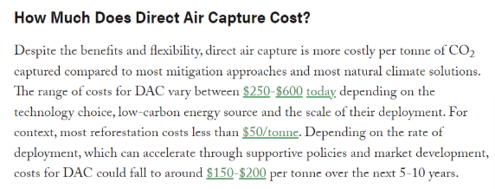

// Most Direct Air Capture and other methods of collecting CO2 are done on a large scale

### Transportation

**Safely Transporting CO2** | <https://www.linde-gas.com/en/images/Safe%20Transport%20of%20Gas_tcm17-13904.pdf>

Helpful article about the trading of carbon emissions | <https://www.thebalance.com/carbon-emissions-trading-3305652>

### Notes about CO2 Enrichment Consider

**Information below is sourced from<https://extension.okstate.edu/fact-sheets/greenhouse-carbon-dioxide-supplementation.html> **

**Cons to Consider:**

* Greenhouses may not need CO2 at the time it is produced, meaning the CO2 supplementation may not be required year-round (see “When to apply” below
* It is pricey for greenhouses to introduce CO2 enrichment and therefore may not want to begin (i.e., costs for greenhouse modifications)
* Excess CO2 can be toxic to plants, this may cause difficulty with partnerships
* Pure CO2 must be used

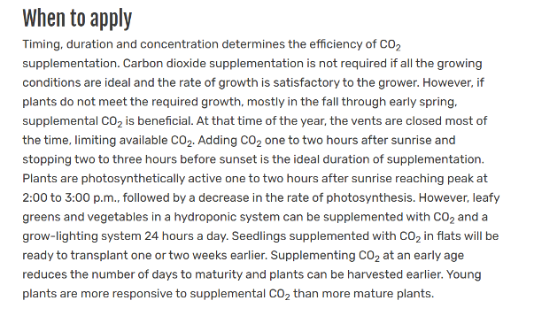

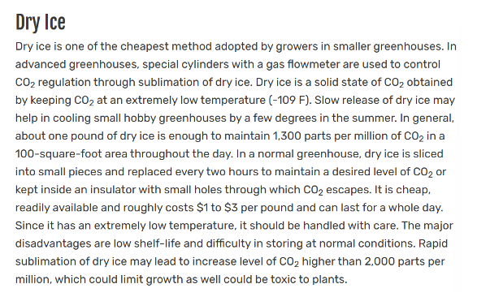

### How CO2 Enrichment is Implemented

DIY CO2 Generators for Greenhouses and Hydroponics | <https://luv2garden.com/hydroponic_c02_diy.html#:~:text=A%20very%20basic%20Carbon%20Dioxide,will%20boost%20the%20c02%20levels>

**Universal Grow Controls** |<http://universalgrowcontrols.com/CO2-Enrichment>

- They build custom CO2 enrichment systems for greenhouses, including the tanking systems

**Universal CO2 enrichment systems |**<https://universalco2.com/CO2-Enrichment>

# Part 2: Greenhouse/CO2 Partnerships Research

## DIY Option:

Creating a Partnership with a local greenhouse supplier

* Buy the greenhouse materials from a supplier that can be a neighborhood greenhouse
* Plants can be obtained through wholesale

## Existing and Established:

Create a Partnership with an existing greenhouse

* Establishing a CO2 exchange with an already existing greenhouse

### Local Greenhouses/Suppliers

Phelan Gardens (<https://phelangardens.com/> )

- Nursery for Non-food related plants and vegetation

Phone | (719) 574-8058

Harding Nursery (<https://hardingnursery.com/products/vegetables/> )

- Wholesale Nursery for supplies as well as vegetables

Rick’s Garden Center ([https://www.ricksgarden.com/#](https://www.ricksgarden.com/) )

- Gardening Supplies

Phone | (719) – 632 - 8491

### US Greenhouses

A list of the top growers in the US |<https://www.greenhousegrower.com/crops/the-top-fresh-produce-greenhouse-growers-in-the-u-s/>

List of Indoor Farming Companies |<https://www.ventureradar.com/keyword/indoor%20farming> (not all are in the US)

### Large Greenhouses

Below are some Greenhouses and information about them and their programs.

Collins Brothers Produce |<https://www.collinsproduce.com/>

- There is a form that can be filled out for inquiries, they might be able to link the business to potential local and other greenhouses

Green Spirit Living Microgreens |<https://www.greenspiritliving.com/about>

- They grow microgreens indoors in Northport, MI

- For contact | Linda@greenspiritliving.com or

There is a form to fill out here --><https://www.greenspiritliving.com/contact>

Bowery Farming |<https://boweryfarming.com/farms/>

- Bowery turns industrial spaces into smart farms indoors

- Their Kearny Farm |<https://boweryfarming.com/kearny-farm/>

o Kearny, NJ

o Former site of the Federal Shipbuilding & Drydock Company which is a shipyard built for ships during WW1 and 2

o Growing more than 5.5 tons of produce per day

- Their Nottingham Farm |<https://boweryfarming.com/nottingham-farm/>

o Nottingham, MD

o 100 times bigger than Kearny

o Indoor vertical growing

AeroFarms |<https://www.aerofarms.com/>

- Commercial Partnerships |<https://www.aerofarms.com/commercial-partnerships/>

o “To Solve Agriculture’s Toughest Challenges”

- Corporate Farm Partnerships |<https://www.aerofarms.com/corporate-farms/>

- Community Farm Partnerships |<https://www.aerofarms.com/community-farms/>

Plenty |<https://www.plenty.ag/about-us/>

- They aim to provide greens to communities in need

- Indoor and environmentally friendly

* Look for established greenhouses
  + One of the largest consumers of CO2 gas is large indoor greenhouses. These greenhouses can grow crops at a density of up to 400x that of traditional methods.

CO2 Funding Requirements:

* + Are they willing to part with their byproducts? Or do they already have a use for the CO2?
  + Do they contain CO2? Or release it into the atmosphere?
* CO2 is collected in a garage, filtered, and delivered to a nearby greenhouse
* Targeting vertical greenhouses
  + Most large vertical greenhouses are located in or around densely populated areas where their extreme growing efficiency can be taken advantage of. Because these locations are near dense population centers, it increases the potential client base of car owners who would be using a dry ice blasting service.
  + Very efficient use of growing space
  + Require large amounts of CO2

## Greenhouse Methodology

Greenhouse Keywords:

“Large Indoor Greenhouse”, “Vertical Greenhouses”, “Community Gardens”, “Biggest Greenhouses in the US”, “Large Indoor Farms”, “Large Enclosed Greenhouses”, “Large Square foot Greenhouses”, “Large Enclosed Greenhouses”

Greenhouse Requirements:

* + Location, is it able to connect to a Boreas facility?
  + Large CO2 requirements? How large is it? What are the CO2 capabilities?
  + Availability of land or an existing space for garage construction
  + Are they financially able to take on CO2 enrichment?
  + Are they open to partnering?

** See Appendix A for a full Greenhouse Criteria List **

## 

## Brewing and CO2

Earthly Labs | (<https://earthlylabs.com>)

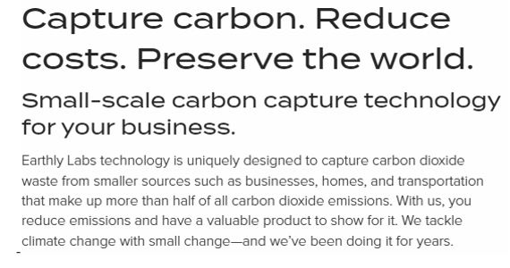

* Earthly Labs’ solutions involve capturing extra CO2 from the brewing process and repackages it to be used in greenhouses around Colorado

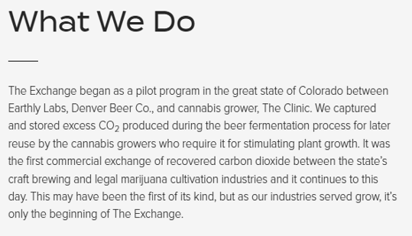

* Earthly Labs took a similar approach of finding a small ecosystem where CO2 recycling and exchange would be beneficial for all parties involved and could be used as a successful blueprint.

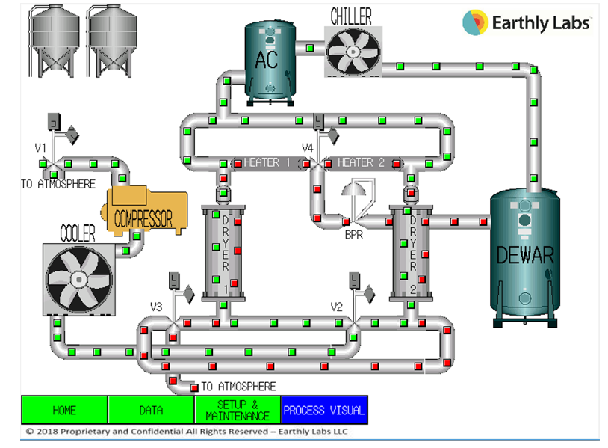

*Above is an example of a Earthly Labs CO2 reclamation system used by companies such as Devner Beer CO.*

# 

# Part 3: Funding Opportunities Research

## *FEDERAL SMALL-BUSINESS GRANTS*

[**Grants.gov**](https://www.grants.gov/web/grants/applicants/apply-for-grants.html)**:** Grants.gov is a comprehensive database of grants administered by various government agencies, such as the Education Department and the Department of Veterans Affairs.

[**Small Business Innovation Research and Small Business Technology Transfer programs**](https://www.sbir.gov/sbirsearch/solicitation/current)**:** The SBIR and the STTR grant programs focus on research and development for technology innovation and scientific research. The programs help connect small businesses with federal grants and contracts from 11 government agencies.

**\*\*To qualify, you must operate a for-profit business, have no more than 500 employees, and meet other** [**eligibility requirements**](https://www.sbir.gov/sites/default/files/elig_size_compliance_guide.pdf)**.\*\***

[**Idea Café’s Small Business Grant**](https://www.businessownersideacafe.com/business_grants/)**:** Idea Cafe is a community-driven website where the website staff and users interact with one another. Giving access to think tanks, community outreach, and assistance with loans and grants.

* **National Institute of Foods and Agriculture**
  + **Key Words**
    - Agriculture
    - Food and Nutrition
    - Business
    - Environment
    - Sustainability
  + **Funding Range**
    - $10,000,000 - $15,000,000
  + **Grant Opportunities -- Agricultural and Food Research Initiative** 
    - **Agricultural Systems** 
      * Applications that take a systems approach for projects; significantly improve the supply of affordable, safe, nutritious, and accessible agricultural products, while fostering economic development and rural prosperity in America.
    - **Foundational and Applied Science Program**
      * **Focuses on** -- Plant and animal health and production. Food safety, nutrition, and health. The bioenergy, natural resources, and environment sector. Agriculture systems and technology. Finally, agriculture economics and rural communities
    - **Program Education and Workforce Development Program**
      * Aims for education and workforce development. Focuses on developing the next generation of research, education, and extension professionals in the food and agricultural sciences.
* **National Institute of Science**
  + **Key Words**
    - Sustainability
    - Agriculture
    - Food and nutrition
    - Business
    - Environment
    - Innovation
    - Development
  + **Grant Opportunities**
    - **Environmental Sustainability**
      * Promote sustainable engineered systems that support human well-being and that are also compatible with sustaining natural systems. The program supports engineering research that seeks to balance society's need to provide ecological protection and maintain stable economic conditions.
    - **Partnerships for Innovation**
      * Identifying and supporting NSF-sponsored research and technologies that have the potential for accelerated commercialization while maintaining the goal to promote sustainable engineered systems that support human-well being and are compatible with sustaining natural systems.
* **Natural Resources Conservation Service**
  + **Key Words**
    - Agriculture
    - Food and Nutrition
    - Business
    - Environment
    - Sustainability
  + **Funding Range**
    - $5,000,000
  + **Grant Opportunities** 
    - **Partnerships for Climate-Smart Commodities**
      * Provide a plan to pilot implementation of climate-smart agriculture and/or forestry practices on a large scale, including meaningful involvement of small or historically underserved producers
* **National Science Foundation**
  + **Key Words**
    - Agriculture
    - Food and Nutrition
    - Business
    - Environment
    - Sustainability
    - Engineering
    - Green
  + **Funding Range**
    - $10,000,000
  + **Granting Opportunities**
    - **Environmental Engineering**
      * The goal of the Environmental Engineering program is to support potentially transformative fundamental research that applies scientific and engineering principles to prevent, minimize, or re-use solid, liquid, and gaseous discharges of pollution to soil, water, and air by closing resource loops or through other measures. Mitigate the ecological and human health impacts of such releases by smart/adaptive/reactive amendments or manipulation of the environment, and remediate polluted environments through engineered chemical, biological, and/or geophysical processes
* **Office of Science**
  + **Key Words**
    - Small-Team
    - Environment
    - Sustainability
    - Engineering
    - Chemicals
    - Materials
    - Carbon
  + **Funding Range**
    - $200,000 - $1,500,000
  + **Granting Opportunities**
    - Chemical and Materials Sciences to Advance Clean Energy Technologies and Low-Carbon Manufacturing
      * The DOE SC program in Basic Energy Sciences announces its interest to form small teams to advance fundamental chemical and materials sciences that underpin clean energy technologies and low-carbon manufacturing. For this FOA, clean energy technologies include approaches to capture, produce, convert, store, and use energy that reduces or eliminates unwanted emissions such as greenhouse gasses.
* **Other Funders**
  + **Entrepreneurship Grant -- Denver**
  + **Key Words**
    - Entrepreneurship
    - Denver
    - Small Business
    - Grant
  + **Funding Range**
    - ~$1000
  + **Charitable Gift Fund**
    - **Key Words**
      * Entrepreneurship
      * Microfinance
      * Denver
      * Business Promotion
      * Grant
    - **Funding Range**
      * ~$1000

## **PRIVATE FUNDERS**

* **Venture Capitalists** -- <https://hbr.org/1998/11/how-venture-capital-works>
  + Venture capitalists are large entities that seek out investments that fit within their field, though only making up a small portion of the overall scope for the firm. Allowing them to invest in the record of the portfolio rather than the business itself -- [**Article**](https://www.thebalancesmb.com/the-basics-of-venture-capital-for-small-businesses-393402).
  + Private Companies or Individuals
    - Seed Financing
    - Startup Financing
    - First-Stage Financing
    - Second-Stage Financing
    - Mezzanine (Bridge) Financing
* **Loan Programs** -- [**Accion**](https://www.accion.org/)
  + SBA Loans
    - **Best for:** Businesses that don't meet traditional banks' strict lending criteria.
      * Traditional banks, a federal guarantee on your loan
      * Less risky for banks to lend you the funds you need
      * The SBA also connects you with favorable rates offered by traditional lenders
    - There are multiple types of [SBA loans](https://www.nerdwallet.com/article/small-business/small-business-loans-sba-loans) available
      * SBA 7(a) loans
      * SBA 504 loans
      * SBA microloans
    - The most popular of the SBA loan programs, 7(a) loans can be used for a wide variety of funding purposes and are available in amounts up to $5 million.
    - **Note: Although SBA loans can be easier to access compared to bank loans, you’ll still need to meet top criteria — a good credit score (FICO 690 and up), strong annual revenue, and at least two years in business — to qualify. **
  + Personal Business Loans
    - Private Lenders are institutions such as banks or other large institutions that commission an interest service that seeks to make a profit. Where private lenders have the luxuries of choice, these institutions focus primarily on the possible profitability of the said business.
      * Lending Club
      * Upstart, upgrade
      * Rocket Loans
      * Laurel Road
      * Discover
* Other Possible Funding Opportunities
  + Crowdfunding/ Kickstarter
    - Community Driven Funding where your message can be reached by real people.
  + Business Credit Cards
    - Creating business-based accounts allow for a bank to only ‘put a toe in the water.’
  + Equipment Financing
    - Financing or other equipment acquisition means can prove to be beneficial. Especially towards the initial startup of the company.
  + Friends and Family loans

**\*\* See Appendix A for a full Greenhouse Criteria List \*\***

# 

# 

# Conclusion

Overall the team has accomplished all the tasks outlined in the scope of work and has compiled a deliverable that is sufficient to assist Boreas CO2. The team has provided Boreas CO2 with a foundation to further seek partnerships and funding in the future. Not only were potential partners found but the team also found multiple adequate funding options that meet the specific criteria of Boreas CO2.

The team believes that with these tools Boreas CO2 will be more likely to accomplish its goals and be more likely to reach a net-zero status in the future in order to sustain the environment. Moving forward the team wishes Boreas CO2 well in the future search for funders and greenhouse, as well as beginning to contact and make those partnerships reality.

Again the team would like to thank you for the amazing research opportunity that Boreas has presented. The team was able to greatly improve their research skills using both public and private databases. Additionally working under constraints such as location, cost, and sustainability helped the team really understand the limitations of building a business with real-world restrictions. Ultimately because of this experience, the team was able to realize the true difficulty of starting a new business and how to persevere through obstacles.

We truly feel that Boreas CO2 has a place in the industry and that it will be successful due to its planning strategy and truly net-zero operation goal. With the tools provided and the lack of competitors, Boreas CO2 is in the best position to jump off the ground and start serving its customers and community alike! Altogether the team wishes you the best of luck, please don’t hesitate to reach out to any of us in the future through our listed contact methods!

Sincerely,

Boreas CO2 Bachelor of Innovation Team

# Appendix

## **Appendix A**: List of Potential Greenhouse Partners

| Name of Greenhouse | Parent Co. | Location | Farm/Greenhouse Size (m^2) | Annual Revenue/Budget | CO2 Potential (kg) |
| --- | --- | --- | --- | --- | --- |
| Bright Farms | Cox Enterprises | Selinsgrove, PA | 26012 | $32.4 M | 1123.7184 |
| App Harvest | N/A | Morehead. KY | 242811 | $350 M | 10489.4352 |
| Green Empire Farms | Mastronardi Produce LLC | Oneida, NY | 242811 | $4.7 M | 10489.4352 |
| Revolution Farms | N/A | Caledonia, MI | 7896 | $5 M | 341.1072 |
| Mastronardi (Michigan) | Mastronardi Produce LLC | Coldwater, MI | 388498 | $1.48 B (Combined) | 16783.1136 |
| Kearny Farm | Bowery Farming | Kearny, NJ | 130000 | $300 M | 5616 |
| Nottingham Farm | Bowery Farming | Nottingham, MD |  | $300 M | 0 |
| AeroFarms | N/A | Newark, NJ | 6503 | $100 M | 280.9296 |
| lēf Farms | Bright Farms | Loudon, NH | 6968 | $32.04 M | 301.0176 |
| Hendersonville Farm | Bright Farms | Henersonville, NC | 26013 | $32.04 M | 1123.7616 |
| Vertical Roots Farms | AmplifiedAg | Charleston, SC | Columbia,SC | Atlanta, GA | 5574 | $40 M | 240.7968 |
| Plenty | N/A | San Francisco, CA | 8825 | $134 M | 381.24 |
| Gotham Greens | Gotham Greens | Brooklyn, NY | 1858 | $8.4 M | 80.2656 |
| Gotham Greens | Gotham Greens | Brooklyn, NY | 1394 | $6.3 M | 60.2208 |
| Gotham Greens | Gotham Greens | Queens, NY | 5574 | $25M | 240.7968 |
| Gotham Greens | Gotham Greens | Chicago, IL | 6968 | $31.7 M | 301.0176 |
| Gotham Greens | Gotham Greens | Chicago, IL | 9290 | $42 M | 401.328 |
| Gotham Greens | Gotham Greens | Providence, RI | 9290 | $42 M | 401.328 |
| Gotham Greens | Gotham Greens | Baltimore, MD | 9290 | $42 M | 401.328 |
| Gotham Greens | Gotham Greens | Denver Metro, CO | 2787 | $12.6 M | 120.3984 |
| 17999 County Road 4 Brighton | Tagawa GreenHouse Ent | Golden, Co | 78967 | ~$23.05 M | 3411.3744 |
| Windset Farms | Windset Farms | Santa Maria, CA | 679872 | - | 29370.4704 |

## **Appendix B:** List of potential Funders

| Name of Grant/Program | Name of Funder | Funding amount | Deadlines (application) | Keywords | Location (if applicable) | Limitation (ie. Federal?, restrictions, etc.) |
| --- | --- | --- | --- | --- | --- | --- |
| Entrepreneurship Grant | The Denver Foundation | ~$1,000 | March 1st (spring cycle) August 1st(fall cycle) | Entrepreneurship | Denver | - |
| Charitable Gift Fund | Fidelity Investments | ~$1,000 | NA | Business promotion, entrepreneurship, microfinance | NA | Grants are National (US) only |
|  | Rockefeller Brothers Fund, Inc |  | Board meetings: Mar, June, Nov | Air Quality, Climate | N/A | - |
| Agriculture and Food Research Initiative Competitive Grants Program Education and Workforce Development Program | National Institute of Food and Agriculture | $10,000,000 | 10/27/2022 | Agriculture, food and nutrition, business, environment | N/A | Federal |
| Agriculture and Food Research Initiative - Foundational and Applied Science Program | National Institute of Food and Agriculture | $15,000,000 | 12/31/2022 | Agriculture, food and nutrition, business, environment | N/A |  |
| Agriculture and Food Research Initiative Sustainable Agricultural Systems | National Institute of Food and Agriculture | $10,000,000 | 7/28/2022 | Agriculture, food and nutrition, business, environment | N/A | Federal |
| Partnerships for Climate-Smart Commodities | Natural Resources Conservation Service | $5,000,000 | 5/27/2022 | Agriculture, food and nutrition, business, environment | N/A | Federal |
| Environmental Sustainability | National Science Foundation | 7,066,000 | Proposals accepted anytime | Sustainability, agriculture, food and nutrition, business, environment | N/A | Federal |
| Partnerships for Innovation | National Science Foundation | $550,000 | 7/13/2022 | Innovation, development, sustainability, agriculture, food and nutrition, business, environment | N/A | Federal |
| FY22 Carbon Utilization Technology: Improving Efficient Systems for Algae | FY22 Carbon Utilization Technology: Improving Efficient Systems for Algae  Department of Energy  Golden Field Office | Ceiling $3.0M  Floor $2.0M | 7/13/2022 | Carbon, Aloge, Energy, Corporation | N/A | Federal |
| Environmental Sustainability | National Science Foundation | $7.06M | Proposals accepted anytime | Environmental Sustainability, Carbon, Green | N/A | Federal |
| Chemical and Materials Sciences to Advance Clean Energy Technologies and Low-Carbon Manufacturing | Office of Science | Ceiling $1.5M  Floor $200k | 17-May-22 | Chemicals, Materials, Carbon, Small team | N/A | Federal |
| Sustainable Landscapes Broad Agency Announcement | Agency for International Development | NO INFO | 24-Sep-22 | Landscape, Development, Carbon, Green | N/A | Federal |
| Environmental Engineering | National Science Foundation | $10.0M | Proposals accepted anytime | Green, Engineering, Environmental | N/A | Federal |

## 